Linear Image Processing

Q1)
- As it can be used to detect edges, corners or extract features from images
- Used to get the magnitude and orientation of edges, Steps of it’s usage are
  - Calculate magnitude and orientation
  - threshold the output to only keep strong edges
  - perform Non Maximal Suppression to keep only 1 pixel wide edges
  - Link Weak edges to Strong one by using a low and high thresholds

Q2)

- 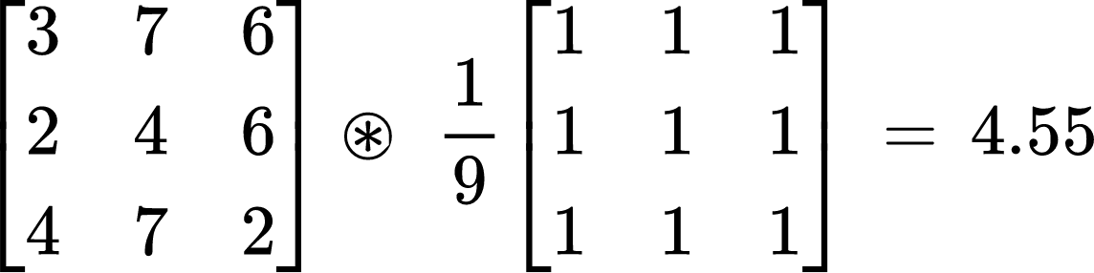
- [ 2 2 3 4 4 6 6 7 7] < window around (1,1) sorted
^ median
- 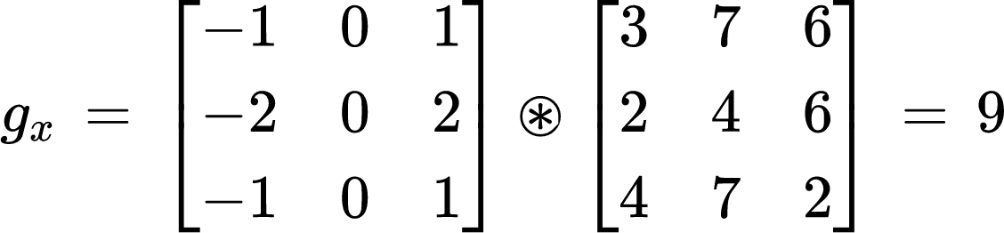
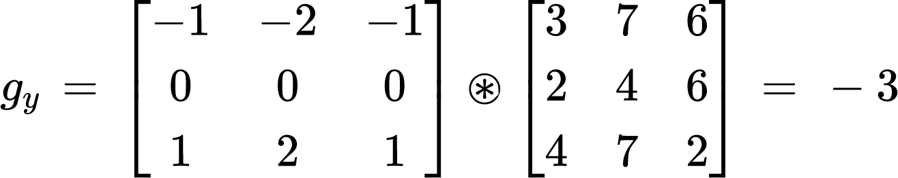
$gradient magnitude = \sqrt{({{g_{x}}^{2}}^{} + {g_{y}}^{2})} = 9.486$

Q3)
- Sharpening, by applying a smoothing filter on the image then subtracting the smoothed image from the original then adding the result to the original image to enhance edges
- Sharpening, by applying a smoothing filter on the image then subtracting the smoothed image from the original then adding the result to the original image to enhance edges

Q4)
The Convolution process flips the kernel in the x and y directions.
The results from the laplacian filter won’t be different since the kernel is symmetric so flipping it yields the same kernel

Q5)
Increasing the variance increase the range of values that the filter can take which causes more smoothing/noise removal

Q6)
- Due to the Associative property of convolution
- The second, because it saves a convolution process on the image
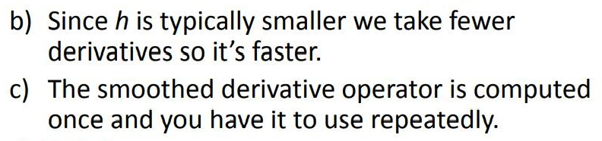(Lec 3, 38)

Q7)
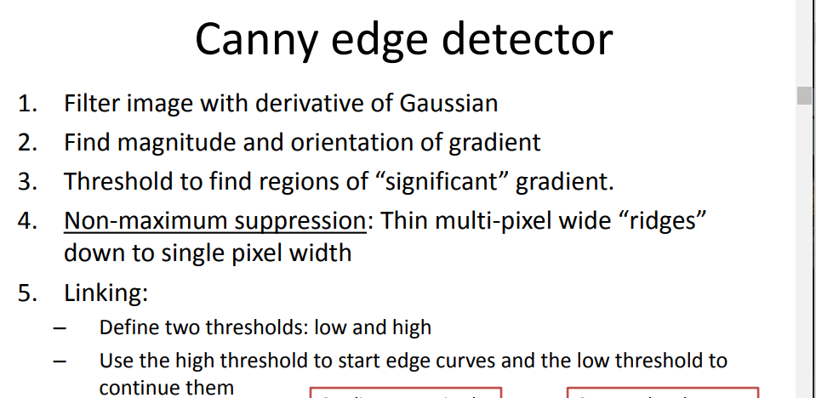

Features

Q1)
What: Second-moment matrix is an approximation of the change in appearance in the window when shifting it by values u,v where u and v are near 0.

Role: It’s role is to detect presence of edges or corners
By evaluating the $λ$ in the matrix we can detect corners which are considered good features
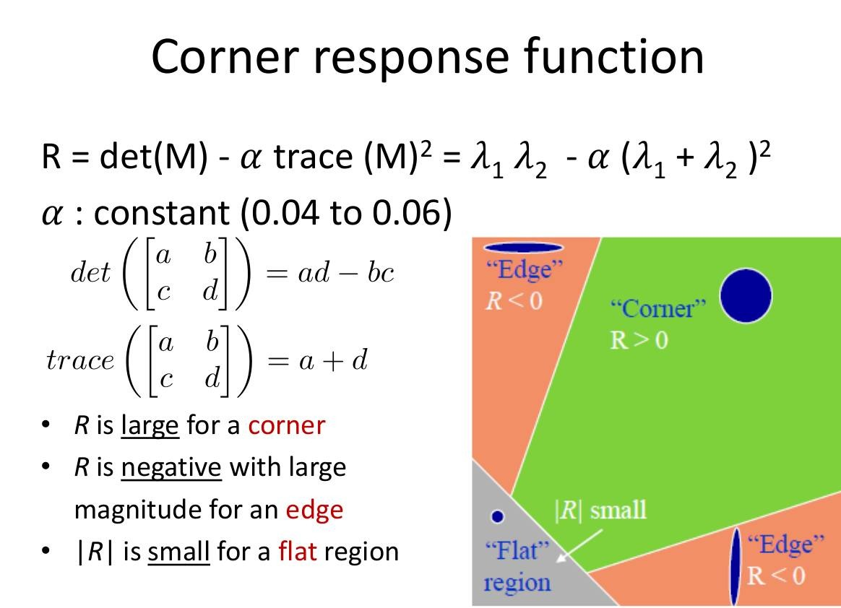

Q2)
- It means that the same descriptor can be calculated from an image before and after the transformation X
Examples: Rotation, Scaling
- Because it will be robust to changes in the image, if it contains the same feature then it will be able to be detected despite scaling, rotation, etc.
- Feature detector: is an algorithm for extracting important points in an image. (e.g. Harris Detector)
Feature Descriptor: “Is a representation of an image that simplifies the image by extracting useful information and throwing away extraneous information.”(Lec 4, 29) (e.g. SIFT)
- 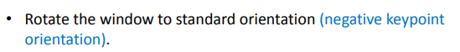(Lec 5, 21)

Q3)
SIFT Detector,
(Lec 5, 21)

Q4)
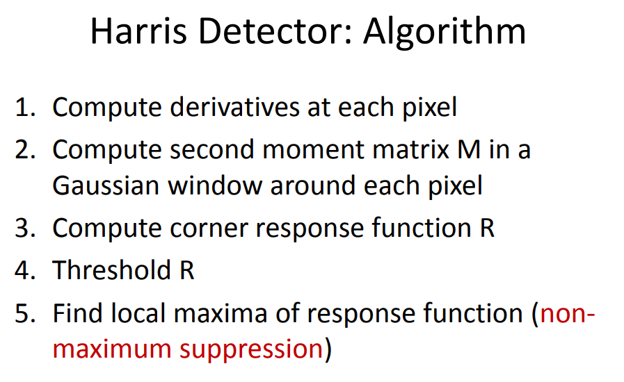
M: matrix used to detect edges and corners
R: Operation applied on M to evaluate its values classifying them to (flat, edge or corner)

